COURSE: CLOUD AND NETWORK SECURITY _C1-2024
STUDENT NAME: LENNIE NTHIGA
STUDENT NO: cs-cns07-24170

WEEK 11 ASSIGNMENT 1
Assignment 1: Azure Monitor

INTRODUCTION
The azure monitor provides services for collecting, analysing, and responding to monitoring data from your cloud and on-premises environments for understanding the performance of the applications and services of azure using of a number of integrated tools
The azure monitor collects and routes data to be monitored using different mechanisms depending on the data being routed and their destination meaning there could an intergration of non-Microsoft tools that can be used .

Exercise 1: Deploy an Azure virtual machine

Step1: Deploy an Azure virtual machine
- Degrading of the azure Az.Compute Module Version to 4.23.0 using Install-Module Az.Compute -RequiredVersion 4.23.0 -Force
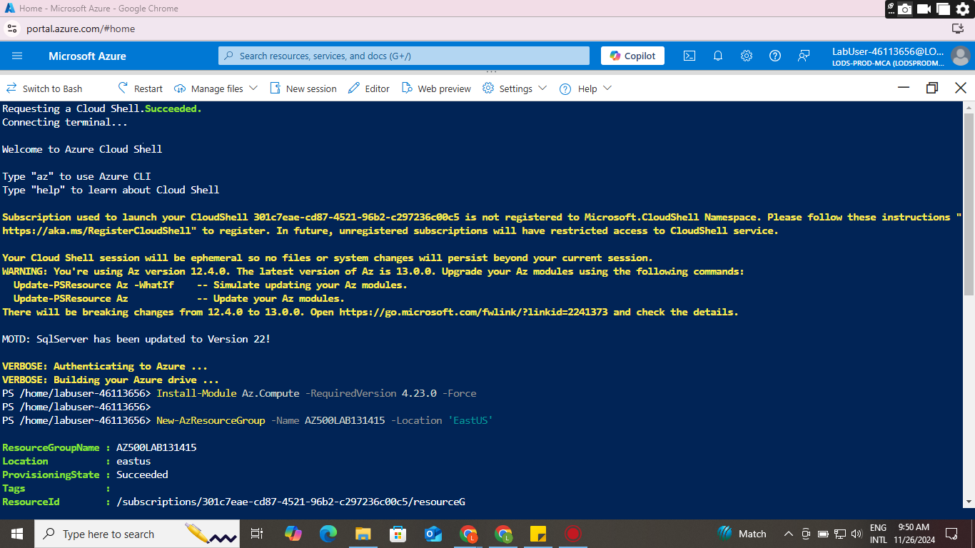
- Creating a resource group in azure PowerShell using New-AzResourceGroup -Name AZ500LAB131415 -Location 'EastUS' and enabling encryption at host (EAH) using Register-AzProviderFeature -FeatureName "EncryptionAtHost" -ProviderNamespace Microsoft.Compute as shown
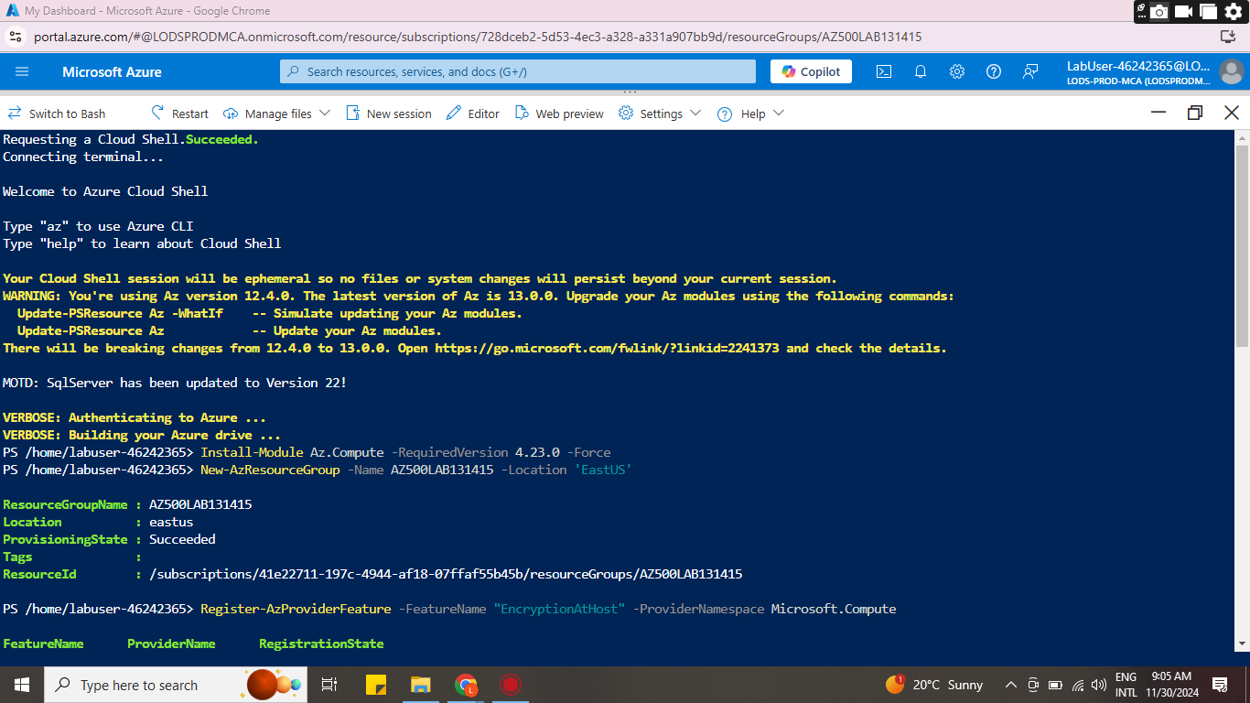
- Create a new azure virtual machine

- D
- D
- D
- D
- Dd
- D
- D
- D
- D
- D
- D
- d

CONCLUSION

